**SECTION A: DISSECTION**

The term ***Dissection*** basicallymeans to expose to view; it is defined as the process of cutting the parts of the specimen aiming to expose several internal organs and systems for the purpose of scientific investigations.

**OBJECTIVES OF DISSECTION**

At the end of this section, a student should be able to understand the dissection of the following three selected specimens:

1. Dissection of a cockroach
2. Dissection of a frog
3. Dissection of a rat

Each **A – level** practical question of dissection will comprises the following distribution of the marks:

* On spot assessment – **05 marks**
* Correct diagram – **01 mark**
* Any 10 labels @ ½ - **05 marks**
* *C*aption ***–*** **½ mark**
* Magnification - **½ mark**
* Theoretical questions – **09 marks**

***Grand total marks – 20 marks***

1. **DISSECTION OF A COCKROACH**

At the end of the dissection of a cockroach, a student should understand the following aspects:

* 1. Introduction of a cockroach
  2. Digestive system of a cockroach
  3. Reproductive system of a cockroach
  4. Nervous system of a cockroach
  5. Dissecting procedures and self-check questions of a cockroach
  6. **INTRODUCTION OF A COCKROACH**

A ***cockroach*** is the large insect commonly used in dissection work as the representative of class insect in the phylum arthropoda.

**Common name:** Cockroach

**Habitat**: In warm conditions, within building crakes or caves.

**Mode of nutrition**: Holozoic nutrition *(Omnivorous).*

**Mode of reproduction**: External fertilization.

**Mode of life cycle:** Incomplete metamorphosis.

**Taxonomy classification:**

**Kingdom**: Animalia

**Phylum**: Arthropoda

**Class**: Insecta

**Order**: Dicytoptera

**Family**: Blattidae

**Genus:** Periplaneta

**Species:** Americana

**Distinctive characteristics of a cockroach**

1. It has one pair of long antennae.
2. It has three pairs of jointed legs.
3. It has two pairs of membranous wings.
4. It has three body parts; head, thorax and abdomen.
5. It has tracheal system for gaseous exchange.
6. It has Malpighian tubule for excretion of nitrogenous wastes.

**Adaptations of a cockroach to its mode of life**

1. Presence of long antennae to detect environmental changes.
2. Presence of compound eyes for wide range of vision.
3. Presence of wings for flight toward the requirements.
4. Presence of exoskeleton for protection and prevents excess water loss.
5. Presence of jointed legs for feeding and locomotion.
6. Presence of brown color helps to hide from the predators.
7. Feed all sources of food such as papers and clothes to ensure survival.
8. Excretion of wastes in the form of uric acid which conserve water
9. Ability to have high reproductive potential to ensure survival chances.

**Table 1.0 sex identification**

|  |  |
| --- | --- |
| **Male cockroach** | **Female cockroach** |
| Narrow abdomen | Wide abdomen |
| Presence of anal style | Absence of anal style |
| Presence of testes | Presence of ovaries |
| Presence of mushroom gland | Presence of collateral glands |
| Absence of prodigal plates | Presence of prodigal plates |

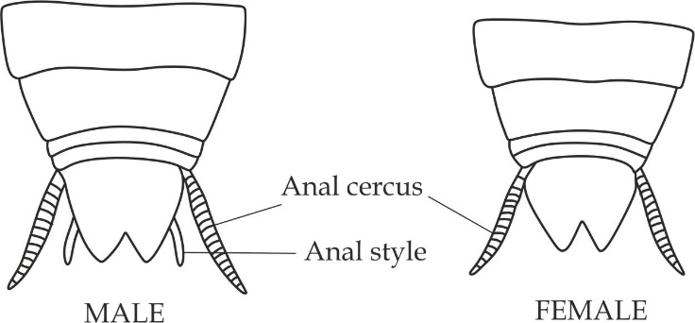

***Figure 1.0*** *Male and female cockroach*

**Economic importance of a cockroach**

1. It is used in biological studies as a specimen for dissection.
2. It is used as food by other organisms.
3. It is used to balance ecosystem by adding nutrients to the soil.
4. It is used in biological control.
5. It is a carrier for diseases causing bacteria like salmonella and E.Coli.
6. It causes damage to properties such as shoes, books.
   1. **DIGESTIVE SYSTEM OF A COCKROACH**

The alimentary canal of a cockroach is long and coiled tubular structure starting from the mouth opening to the anal cercus; it is normally divided into three main parts as shown in figure 6.1:

* Foregut
* Midgut
* Hindgut

***Foregut***

It is the first part of the digestive system of a cockroach which is further differentiated into four main parts; buccal (mouth) cavity, esophagus, crop and gizzard.

1. **Buccal (mouth) cavity**

It is a small chamber in the mouth which consists of the following components:

Role of a buccal cavity

1. For chemical digestion of starch

Adaptations of buccal cavity

1. It has salivary receptacle/reservoir for storage of saliva.
2. It has salivary glands for secretion of saliva which contains amylase enzyme for hydrolysis of starch into maltose.
3. **Esophagus**

It is a short muscular tube structure orients from the buccal cavity and run into the crop.

Role of esophagus

1. It pushes the bolus food from the buccal cavity of the mouth into the crop by peristalsis.

Adaptation of esophagus

1. It is made up elastic circular and longitudinal muscles capable for relaxing and contracting.
2. **Crop**

It is a large pea shaped structure extends from the esophagus, it is like stomach in human.

Role of crop

1. For temporary storage of indigested food.

Adaptation of crop

1. It has large size and elastic muscular wall for maximum storage.
2. **Gizzard**

It is a small circular muscular structure which is located below the crop.

Role of gizzard

1. For grinding and crushing of indigested food.

Adaptations of gizzard

1. It has six cuticular pointed teeth for grinding food.
2. It has thick muscular wall for grinding food as shown in Figure 6.1.

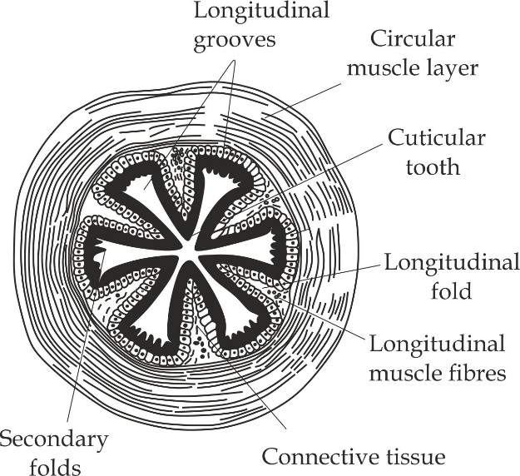

***Figure 1.1*** *structure of a gizzard*

***Midgut - mesenteron***

It is a middle and short coiled part of the digestive system which contains eight pairs of blind tubules called digestive *(hepatic)* caeca.

Role of digestive caeca

1. It is a site for digestion of food substances.
2. It is a site for absorption of digested food substances.

Adaptations of digestive caeca

1. It secretes digestive enzymes for digestion of food substances.
2. It has permeable membrane for the absorption of digested food.
3. It has ***peritrophic membrane*** which protect the midgut from abrasion against food particles.

***Hindgut***

It is highly coiled last part of digestive system consisting of three main organs; ileum, colon and rectum.

1. **Ileum**

It is narrow and coiled tubular structure of the hindgut.

Role of ileum

1. It is the main site for the absorption of the digested food particles.

Adaptations of ileum

1. It is very narrow to facilitate the diffusion of digested food.
2. It is coiled to increase chances for the absorption of the digested food.
3. It has microvilli which increases chances for the absorption of digested food.
4. It has a network of blood capillaries that increase chances for absorption of digested food.
5. **Colon**

It is a wide and longer tubular structure of the hind gut.

Role of hind gut

1. It reabsorbs water from undigested food substances.

Adaptation of colon

1. It is highly folded to increases chances for the reabsorption of water.
2. **Rectum**

It is broader and shorter structure of the hind gut.

Role of rectum

1. It stores undigested food (faeces) prior to egestion.

Adaptation of rectum

1. It has large surface area which increases room for storage of faeces.

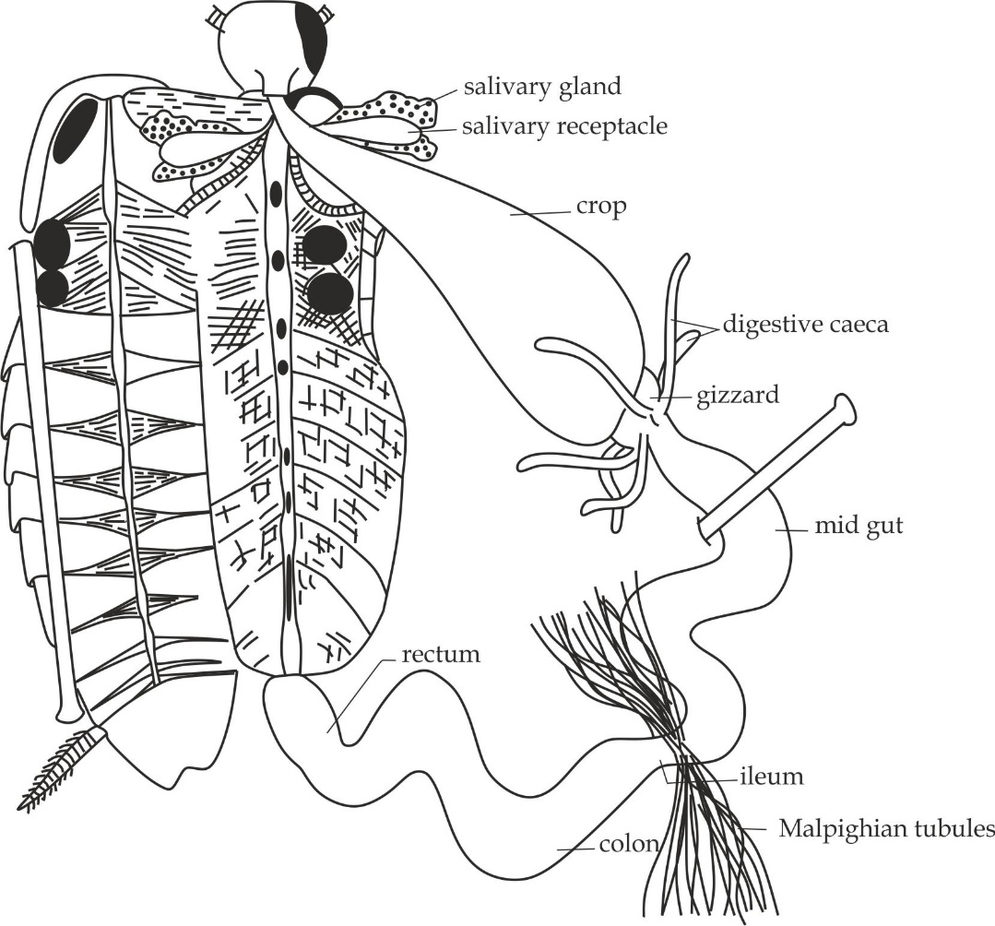

***Figure 1.2*** *digestive system of a cockroach*

***Malpighian tubules***

These are long yellowish structures which eliminate nitrogenous wastes in the form of uric acid from the haemolymph. As the named after their discovery by the ***Marcelo Malpighian***.

Role of Malpighian tubules

They remove metabolic wastes in the form of uric acid; it acts as a kidney.

Adaptations of Malpighian tubules

1. They have microvilli which increases chances for efficient removal of nitrogenous wastes.
2. They are very long to give enough time for the cells in the tubules to absorb nitrogenous wastes.
3. They are slender and thin for rapid diffusion of nitrogenous wastes from the haemocoel into the tubules.
4. The tubules are connected to the ileum for easy transportation of the nitrogenous wastes.

* 1. **REPRODUCTIVE SYSTEM OF A COCKROACH**

In a **cockroach,** sexes are separated *(dioecious);* hence they are two types of reproductive system to be discussed.

* The male reproductive system of a cockroach
* The female reproductive system of cockroach.

***The male reproductive system of a cockroach*** *(Figure 1.2)*

The male reproductive system of a cockroach include four organs which are; testes, vas differentia, mushroom gland and ejaculatory ducts.

1. **Testes (singular; testis)**

These are small lobed masses lying laterodorsally in the fourth to sixth abdominal segments. Testes are not easy seen because they are covered by fatty bodies that conserve optimum temperature for production of viable sperms.

Role of testes

1. They produce male gametes or sperms.
2. **Vas differentia (Singular; Vas deferens)**

These are slender whitish ducts which orients from the testes and run down into the mushroom gland.

Role of vas differentia

1. They carry sperms from the testes into the mushroom gland for the maturation and storage.
2. **Mushroom gland**

It is the mushroom shaped whitish color organ situated at the junction between vas differentia and ejaculatory ducts. It is also called utricular gland.

Roles of mushroom gland

1. It contains seminal vesicles for storage of sperms in form of bundle known as s***permatothecae***.
2. It secretes nutrients for maturation of sperms.
3. **Ejaculatory ducts**

These are wider and elongated ducts which orients from the mushroom gland and opens out by male gonapore (genital pore).

Role of ejaculatory ducts

1. They release sperms out of the male reproductive system.

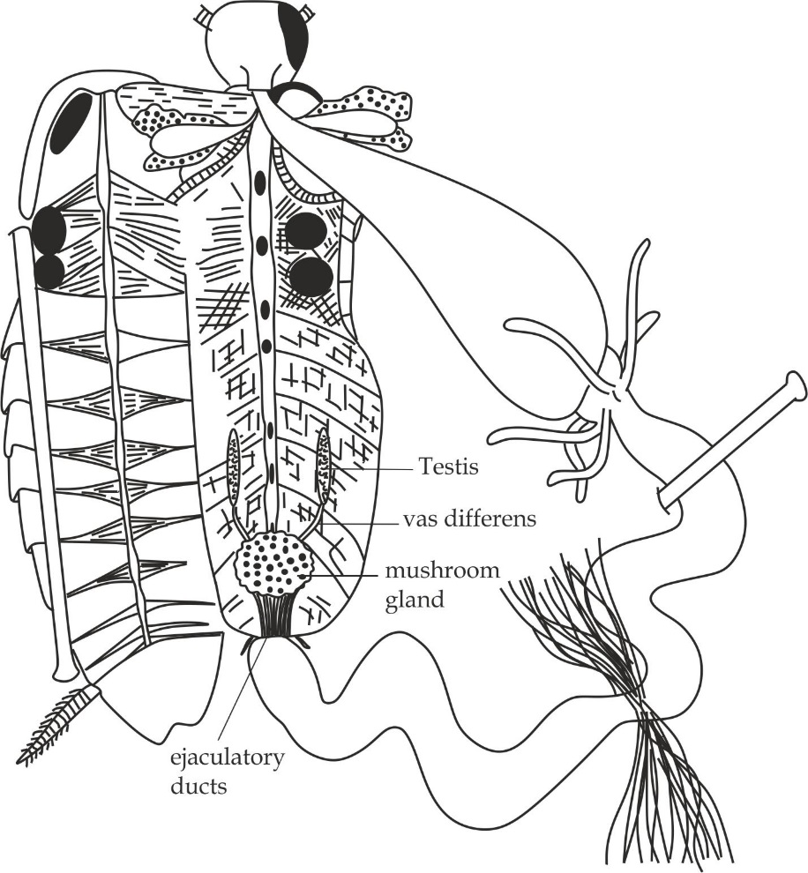

***Figure 1.3*** *reproductive system of a male cockroach*

***The female reproductive system of a cockroach***

The female reproductive system of a cockroach includes five organs which are; ovaries, oviducts, common oviduct, collateral glands and genital chamber.

1. **Ovaries (singular; ovary)**

These are light yellow colored structures located on the lateral sides of the second to sixth abdominal segments, each ovary consists of eight ovaries (ovarian tubules) containing a chain of developing ova.

Role of ovaries

1. They produce female gametes or ova.
2. **Oviducts (singular; oviduct)**

These are slender ducts which connects the ovaries to the common oviduct (vagina) which opens into the genital chamber.

Role of oviducts

1. They carry ova from the ovaries into the common oviduct.
2. **Common oviduct**

It is a tubular structure which is formed by the combination of the two oviducts

Role of common oviduct

1. It receives egg cells (ova) and spermatothecae.
2. **Collateral glands**

These are highly branched tubular glands open on the dorsal side of the genital chamber.

Role of collateral glands

1. They secrete egg case known as ***ootheca***.
2. **Genital chamber**

It is a small pouch into which common oviduct (vagina) opens. It is examined clearly after removing the rectum.

Role of genital chamber

1. It is a site for fertilization.

**Reproduction in cockroaches**

Reproduction in cockroaches is sexual, during copulation spermatothecae are transferred through spermatophores from males. Inside female body eggs are fertilized then are enclosed in capsule called ootheca. An ootheca is a dark reddish color, an average ten ootheca are produced by female cockroach, each contains fifteen fertilized eggs, the ootheca are dropped to a suitable surface at a place with high humidity or near a food and undergoes incomplete metamorphosis as shown in figure 6.3.

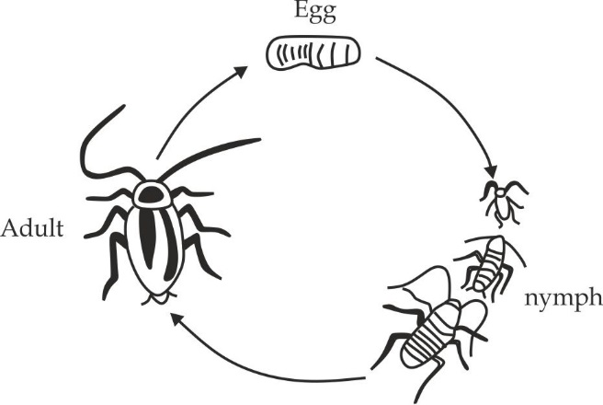

***Figure 1.4*** *Incomplete metamorphosis of a cockroach*

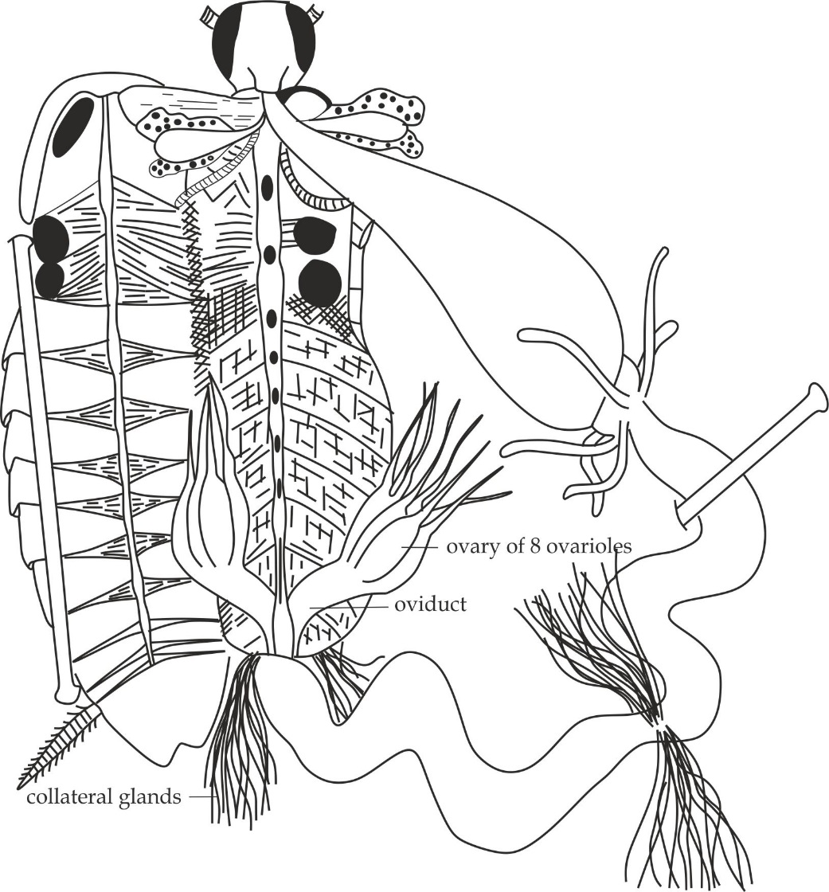

***Figure 1.5*** *reproductive system of a female cockroach*

1. **NERVOUS SYSTEM OF A COCKROACH**

The nervous system of a cockroach is divided into two main parts:

* The central nervous system
* The peripheral nervous system

***The central nervous system of a cockroach***

The central nervous system of a cockroach consists of the sense cells which intercept to form two ganglions;

* Supra – esophageal ganglion
* Sub – esophageal ganglion

**Supra esophageal ganglion**

It is bilobed and whitish ganglion lies in the head and above the esophagus, it is formed by the fusion of three pairs of ganglions which form the brain of a cockroach. *Protocerebrum;* it is the forebrain which is found anterior, *deutocerebrum****;*** it is the midbrain which is found in the middle, *tritocerebrum;* it is found in the posterior*.*

**Sub esophageal ganglion**

It is bilobed pair of the ganglion that lies in the head below the esophagus and extends as a nerve cord.

**Roles of central nervous system**

1. It secretes moulting hormones which controls the metamorphosis.
2. It maintains constant body state.
3. It stores information so that behavior can be modified according to the past experience.
4. It receives information from the antennae, compound eyes, lips and jaw.

***The peripheral nervous system***

The peripheral nervous system of a cockroach consists of the nerve cells which intercept to form the ganglions in the ventral solid double nerve cord, it is divided into two main parts;

* The ventral sympathetic system.
* The caudal sympathetic system.

**The ventral sympathetic system**

This is formed by the nerve cells arising from the three thoracic ganglions in the ventral double nerve cord. Which are prothoracic, mesothoracic and metathoracic.

Role of ventral sympathetic cord

1. It controls the trachea, spiracles, two pairs of wings and three pairs of jointed legs.

**The caudal sympathetic system**

This is formed by the nerve cells arising from the six abdominal ganglions in the ventral double nerve cord.

Role of caudal sympathetic system

1. It controls the digestive organs such as esophagus, gizzard, crop, ileum rectum and reproductive organs in a cockroach.

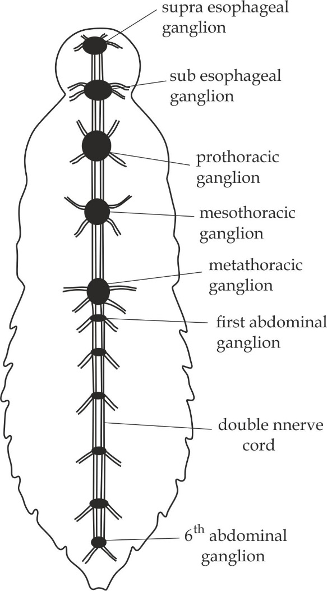

***Figure 1.6*** *nervous system of a cockroach*

**1.5 DISSECTING PROCEDURES AND SELF CHECK QUESTIONS**

***Dissecting procedures of a cockroach***

**Requirements**

* Freshly killed cockroach
* Dissecting tray and water
* Dissecting pins
* Forceps
* Scalpel
* Scissors

**Step one:**

By using a pair of scissors cut the antennae close to the head, wings and legs. Then pins a cockroach to the dissecting tray under water while a dorsal side facing upward as shown in figure 6.5.

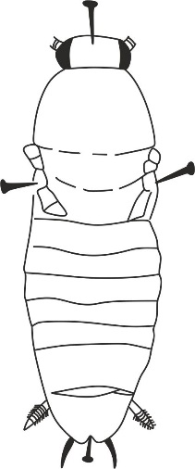

***Figure 1.7*** *a cockroach with dorsal side facing upward*

**Step two**:

Lift the tenth tergum with the forceps and cut the small incision by using a scalpel, through the incision cut up one side of the abdomen and thorax *(make a coronary plane)* as shown in figure 6.6.

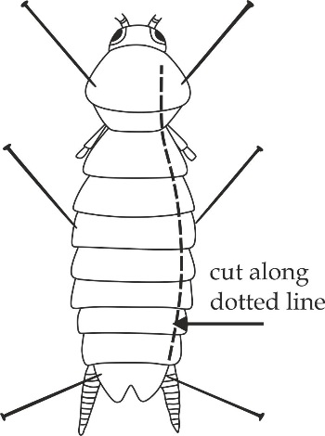

***Figure 1.8*** *a cockroach showing a coronary plane cut*

**Step three:**

Lift up the tergum of the abdomen and thorax and pin against to the other side (use scalpel to cut the muscles and loosen connective tissues when necessary).

**Step four:**

**In displaying the digestive system**; Lift the crop out of the abdomen and push it to one side (do not damage the salivary glands). Use pins to keep alimentary canal out of the way *(remember in displaying cockroach alimentary canal;* ***your*** *left is your* ***right*** *hand and* ***left*** *of the specimen is you’re* ***left*** *and vice versa)*. Clear away fat bodies by squirting them with water and pulling with blunt forceps.

**Step five:**

**In displaying the reproductive system:** Cut the rectum carefully with scissors then examine the mushroom gland in male cockroach and collateral gland in female cockroach *(remember testes in males and ovaries in female cockroach are not easily seen* *because most of the time are accidentally removed away together with fat bodies).*

**Step six:**

**In displaying the nervous system;** remove all the digestive organs and reproductive organs; then observe clearly the double nerve cord with associated ganglions by using magnifying hand lens.

***Self-check questions of a cockroach***

1. **NECTA 2010: 3A**

Dissect the specimen **S1** to fully display the digestive system to your right hand side.

**LEAVE YOUR DISSECTION WELL DISPLAYED FOR PROPERLY ASSESSMENT**

1. Name the structures concerned with:
2. Grinding of food prior to digestion.
3. Increasing the surface area for digestion.
4. Production of saliva.
5. Water reabsorption.
6. Storage of faeces prior to egestion.
7. How are the structures mentioned in above adapted to their roles?
8. **DAR MOCK 2009**

You have been provided with specimen **S1**; dissect the specimen to display the digestive system to fully display the alimentary canal to your right hand side.

1. Draw a large and net diagram of your dissection and label the structures associated with the system asked.
2. Distribute the digestive structures labelled into foregut, midgut and hindgut.
3. Comment on the fact that the digestion of food is confined largely to the midgut and not to the foregut and hind gut.
4. State the sex of your specimen and give one feature you used to determine the sex.
5. What is the mode of reproduction associated with class in which your specimen belongs?
6. State the type of metamorphosis which your specimen undergoes.
7. **MZUKILA PRE NECTA 2008 ; 3B**
8. Dissect the specimen **B1** to fully display the digestive system, Deflect the system to your right hand side. Draw a large well labelled diagram on your dissection.

**LEAVE YOU’RE DISSECTION PROPERY DISPLAYED FOR ASSESSEMENT**

1. Name the structures concerned with:
2. Removal of nitrogenous waste from the blood.
3. Grinding food particles prior to digestion.
4. Production and assortment of enzymes and other secretory products.
5. Most digestion and absorption of nutrients.
6. Production of saliva.
7. How are the structures named in (b) above adapt to their roles?
8. **MTWARA AND LINDI MOCK 2021; 3B**

You have been provided with specimen A1; dissect it in a usual way and pin the alimentary canal in your right hand side.

**LEAVE YOU’RE DISSECTION PROPERY DISPLAYED FOR ASSESSEMENT**

1. Draw a large diagram of your dissection and label the structure only concerned with digestive system, excretory system and reproductive system.
2. Give the adaptation of organs responsible for:
3. Grinding of food.
4. Digestion of food.
5. Temporary storage of food.
6. **MBEYA REGION MOCK 2021**

You have been provided with specimen **S**; dissect it in a usual way. Pin the ileum to your right hand side.

**LEAVE YOU’RE DISSECTION WELL DISPLAYED FOR PROPERLY ASSESSEMENT**

1. Make a neat well labelled diagram of your specimen.
2. Identify the scientific name of your specimen.
3. Write two advantages and two disadvantages of a type of skeleton possessed by a specimen S.
4. Where does specimen **S** common found in its daily life?
5. From your diagram drawn in 1 (a) above mention the parts of digestive system form:
6. Foregut
7. Hind gut
8. What advantage does *gizzard* in specimen **S** be centrally positioned?
9. **MWANZA MOCK 2013; 3A**
10. **You have** been provided with specimen **S1** .Dissect the specimen in a usual way to display the reproductive system. Deflect the gut to the right hand side of the specimen.

LEAVE YOUR DISSECTION WELL DISPLAYED FOR PROPERLY ASSESSMENT

1. Draw and label the structure related to the reproductive system only.
2. State the functions of the structures you have labelled in your diagram.
3. What is the name of structure containing fertilized eggs?
4. **NECTA 2003; 3A**

You have been provided with specimen **F1**, Dissect it in a usual way to fully display the reproductive and excretory system.

1. Make a large and neat well labelled diagram of your dissection.
2. Examine carefully the excretory system with a hand lens and list the structural adaptations which help to increase the total surface area for secretion and excretion.
3. Name one reproductive structure in the animal that are responsible for gamete formation.
4. Leave the dissection displayed.
5. **TAHOSSA 2012**

You have been provided with specimen **G1**, Dissect it in the usual way to fully display the nervous system.

1. Make a large, neat and accurate diagram of your dissection.
2. Label the diagram accurate.

**LEAVE YOUR DISSECTION WELL DISPLAYED FOR ASSESMENT**

1. **PRE NATIONAL 2022**

You have been provided with specimen **K**. Dissect it in usual way to fully display the nervous system*.*

**LEAVE YOUR DISSECTION WELL DISPLAYED FOR ASSESMENT.**

1. **DISSECTION OF A FROG / TOAD**

At the end of the dissection of a **frog** or **toad**, a student should understand the following aspects:

* 1. Introduction of a frog
  2. Viscera in situ and in general of a frog
  3. Digestive system of a frog
  4. Urinogenital system of a frog
  5. Nervous system of a frog
  6. Dissecting procedures and self-check questions of a frog
  7. **INTRODUCTION OF A FROG**

A ***frog /toad*** is commonly used in dissection work as the representative of class amphibian in the phylum chordata.

**Common name**: Frog or toad

**Table 2.1 differences between a frog and toad**

|  |  |
| --- | --- |
| **Frog** | **Toad** |
| It has elongated shape | It has rounded shape |
| It has smooth and moist skin | It has rough and dry skin |
| It has long hind limb for steering when swimming | It has short muscular hind limb for jumping on the land |
| It has protruding eyes | It has non-protruding eyes |

**Habitat**: It is found in grass near swimming ponds or stream.

**Mode of nutrition**: Holozoic nutrition *(carnivorous).*

**Mode of reproduction**: External fertilization.

**Mode of life cycle:** complete metamorphosis.

**Taxonomy classification of a frog:**

**Kingdom**: Animalia

**Phylum**: Chordata

**Class**: Amphibian

**Order**: Anura

**Family**: Ranidae

**Genus:** Rana

**Species:** Temporaria

**Distinctive characteristics of a frog**

1. It has double life, i.e. aquatic and terrestrial.
2. It is cold blooded animal.
3. It has three heart chambers.
4. It has gills for respiration in water and lungs on land.
5. It undergoes external fertilization and the eggs must be laid in water.
6. It has kidneys for excretion of nitrogenous wastes.

**Adaptations of a frog to its mode of life**

1. Presence of protruding eyes assisting to have wide range of vision.
2. Presence of sticky tongue for catching prey.
3. Presence of moist skin for maximum gaseous exchange.
4. Presence of smaller front legs for steering.
5. Presence of long and muscular hind limbs for jumping.
6. Presence of streamlined body with no tail for easy swimming.
7. Presence of webbed feet to support swimming.

**Table 2.1 sex identification of a frog**

|  |  |
| --- | --- |
| **Male frog** | **Female frog** |
| Smaller in size | Larger in size |
| Thick thumb pad | Thin thumb pad |
| Presence of testes | Presence of ovaries |
| Presence of vas deferens | Presence of oviduct |
| Coaking at night | Silent at night |

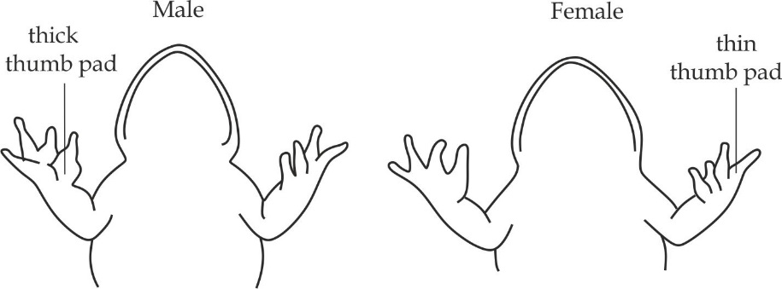

***Figure 2.1*** *the thumb pad of a male and female frog*

**Economic importance of a frog**

1. It is used in biological studies as a specimen for dissection.
2. It is used as food by other organisms.
3. It is used in biological control.
   1. **VISCERA IN SITU AND IN GENERAL OF A FROG**

***Visceral in situ of a Frog***

**Viscera in situ** means all the internal organs in the abdominal cavity of a frog/ toad in undisturbed condition shown in figure 2.2. It includes heart, liver, lungs, gall bladder, stomach, intestine, rectum and bladder.

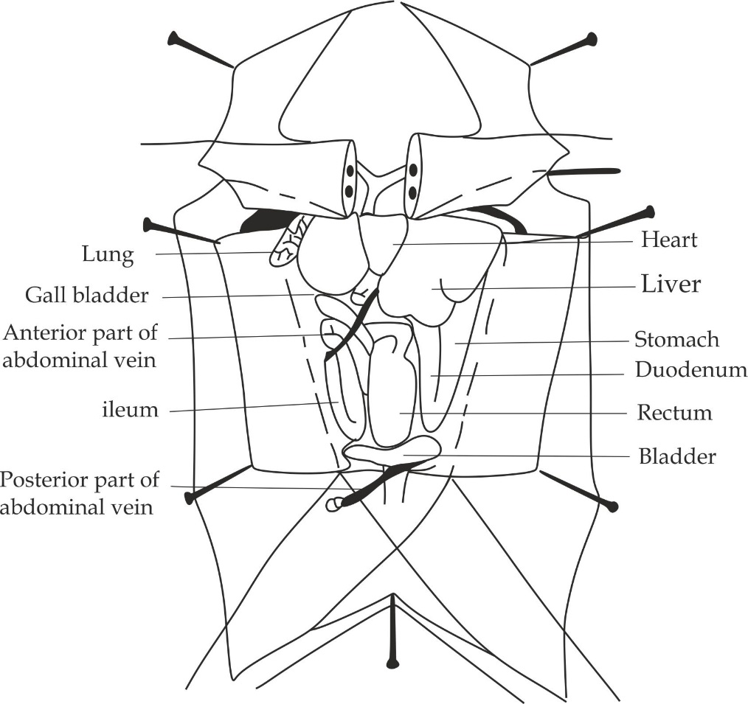

***Figure 2.2 visceral in situ of a frog***

***Visceral in general of a frog***

**Visceral in general** also displays internal organs in the abdominal cavity however being displaced from their original position.

**Visceral in general of a male frog**

**In male frog**, visceral general includes all organs of the visceral in situ in addition to pancreas, mesentery, fat body and testes as shown in Figure 2.3.

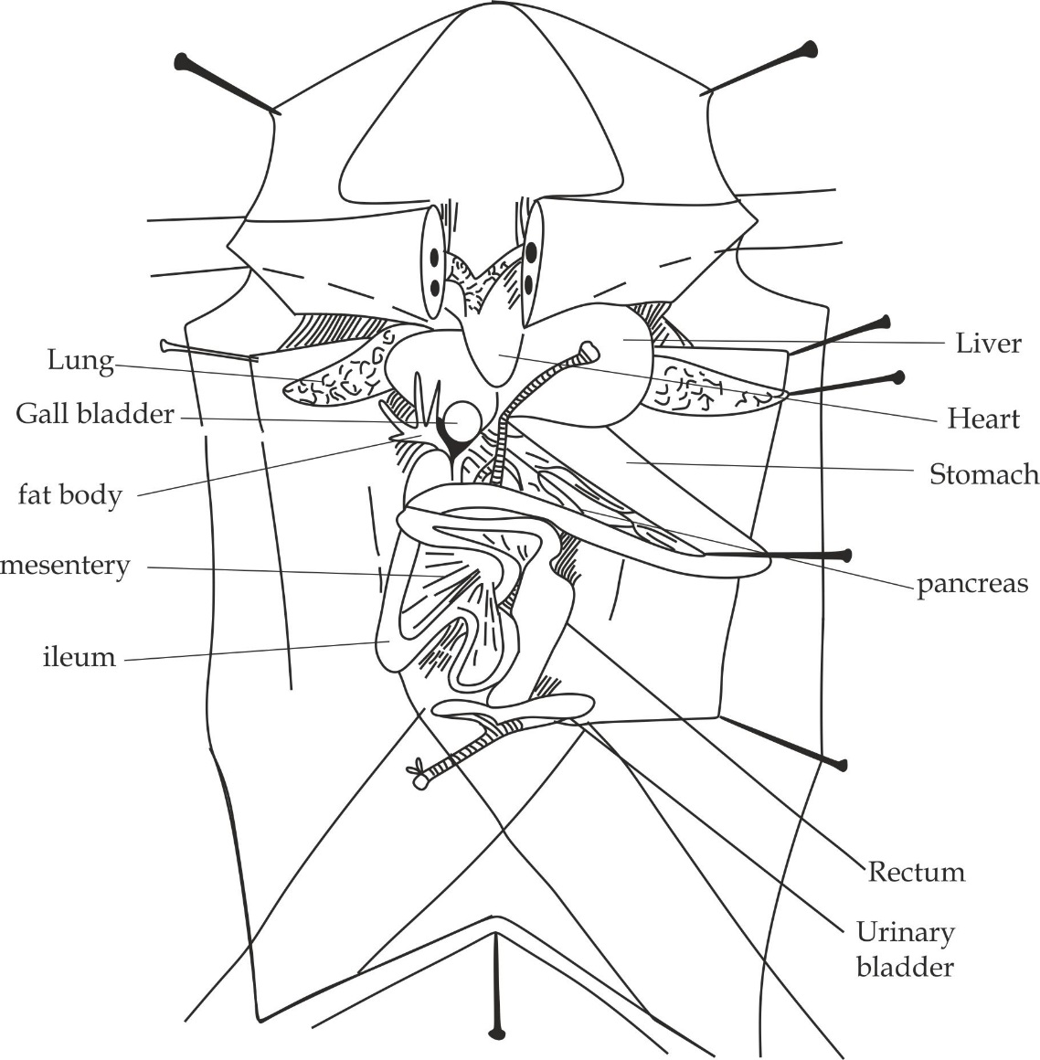

***Figure 2.3*** *visceral in general of a male frog*

***Visceral in general of a female frog***

In **female frog**, visceral general includes all organs of the visceral in situ in addition to pancreas, mesentery, fat body, ovaries and oviduct as shown in Figure 2.3. If your specimen is female, the body cavity may be filled with eggs and enlarged ovary, you must remove first eggs to view other organs Cleary.

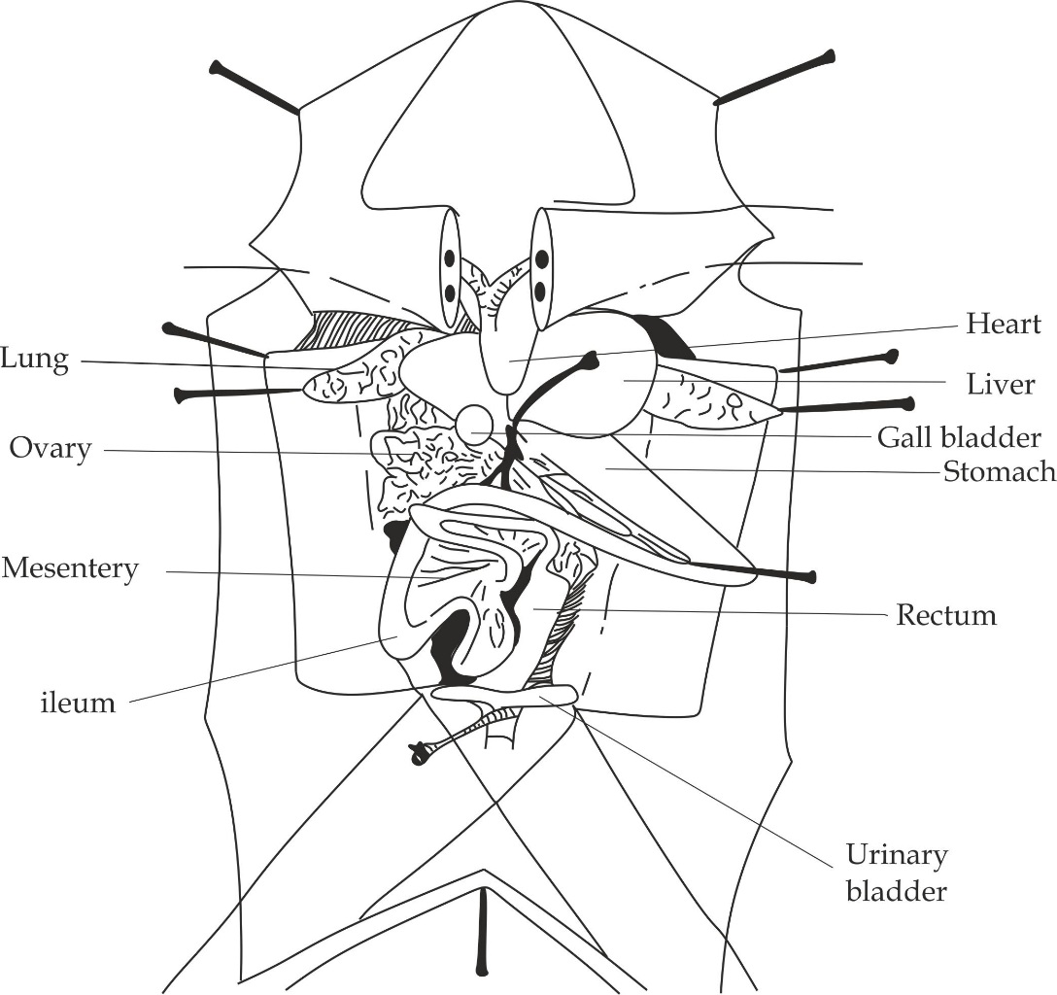

***Figure 2.4*** *viscera in general of a female frog*

* 1. **DIGESTIVE SYSTEM OF A FROG**

The alimentary canal of a frog is long and coiled tubular structure starting from the mouth to the cloaca. It includes buccal cavity, esophagus, stomach, accessory organs (*liver, pancreas and spleen*), duodenum, ileum, rectum and cloaca as shown in Figure 2.5.

1. **Buccal cavity**

It is a wide space between the upper and lower jaw of the mouth, the upper jaw (maxilla) with vomerine teeth and the lower jaw (mandible) with maxillary teeth. Toad has no teeth on the upper jaw.

Role of buccal cavity

1. For mechanical digestion of food.
2. For chemical digestion of starch due to the presence of S. amylase.
3. **Esophagus**

It is short elastic muscular tube that leads from the frogs’ mouth to the stomach.

Role of esophagus

1. It allows the peristalsis movement of bolus food from the mouth to the stomach.
2. **Stomach**

It is a whitish muscular (*pouch)* chamber rising from the lower lip of the esophagus.

Role of stomach

1. For temporary storage of food materials. Since it can expand.
2. For mechanical digestion of food due to contraction of muscles.
3. For chemical digestion of protein due to the presence of pepsin.

1. **Accessory organs**

The digestive accessory organs include liver, pancreas and spleen.

1. **The liver;** this is the largest organ in the frogs body and it is brown in colour composed of three lobes.

Roles of liver

1. For production of bile which is stored in the small green sac under the liver called gall bladder.
2. For detoxification of toxic substances into harmless substances.
3. For storage of glycogen from excess glucose.
4. **The pancreas;** It is a thin, flat and ribbon like structure that lies in between the stomach and duodenum.

Roles of pancreas

1. For secretion of pancreatic juice for digestion of protein, starch and lipids.
2. For secretion of insulin hormone responsible for conversion of excess sugar into glycogen.
3. **The spleen;** It is rounded and dark- reddish structure attached on the mesentery.

Role of spleen

1. For storage of blood as part of circulatory system.
2. **Duodenum**

It is the first section of the small intestine which connects the liver and pancreas to the digressive system. The liver is connected by the bile duct and the pancreas is connected by the pancreatic duct.

Role of duodenum

1. It receives secretion from liver and pancreas via the bile duct and pancreatic duct respectively for digestion of food.
2. **Ileum**

It is the part of the small intestine which is highly coiled and held in place by a blood vessel membrane called the mesentery.

Role of ileum

1. For absorption of digested food materials.

Adaptations of ileum

1. It has villi which increase the surface area for absorption of digested food materials.
2. It is long to increase surface area for absorption of food materials.
3. It is highly coiled to increase time for absorption of food materials.
4. It has microvilli which increase surface area for absorption of food materials.
5. It is well packed with blood capillaries to increase the surface area for the absorption of food materials.
6. **Rectum**

It is shorter and broader tubular part of the large intestine which open into the cloaca. Frogs do not contain **colon**, for this reason only rectum acts as a large intestine.

Role of rectum

1. For temporary storage of undigested food *(faeces)* prior to digestion.
2. For reabsorption of water due to the presence of numerous folds on its wall.
3. **Cloaca**

It is the chamber in the large intestine that receives materials from the digestive, reproductive and excretory system in all vertebrates except in mammals and reptiles.

Role of cloaca

1. It removes undigested food, reproductive cells and urine.
2. **Mesentery**

It is the membrane that holds the coils of the small intestine.

Role of mesentery

1. It carriers absorbed food materials away from the intestine into the body.
2. It contains spleen for storage of blood.

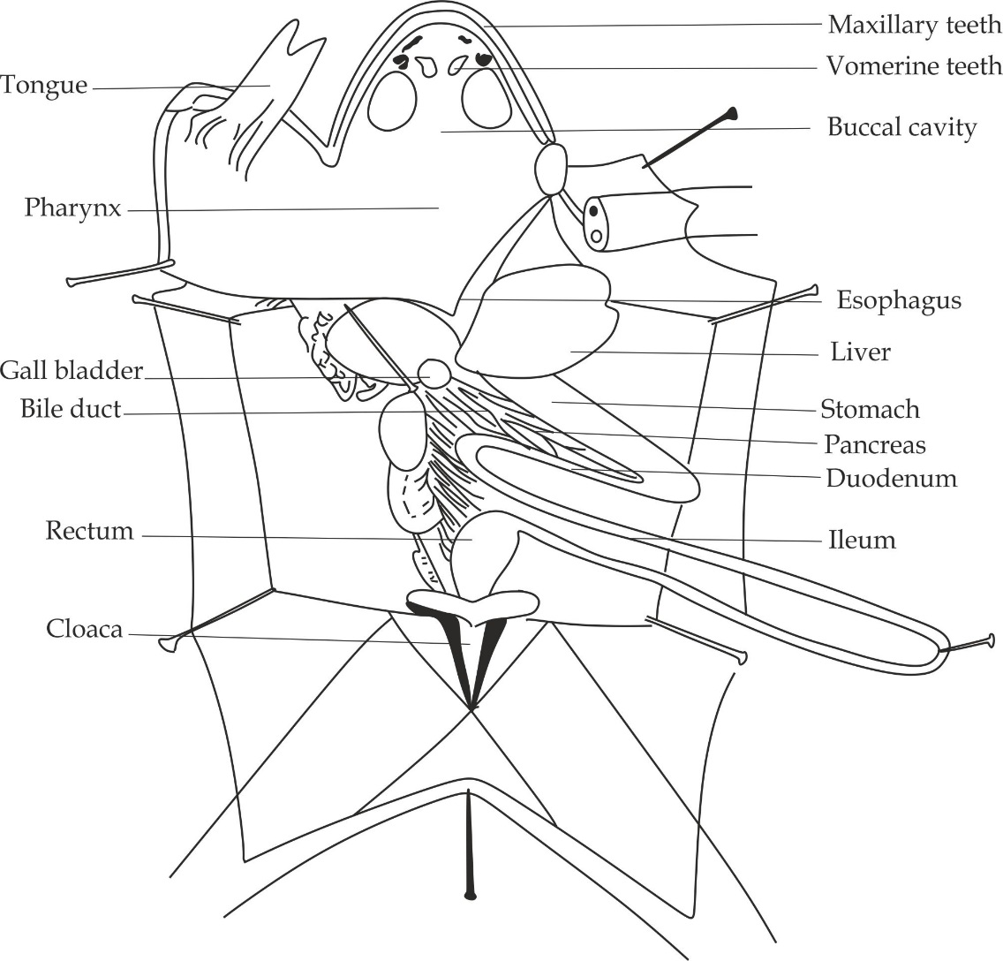

***Figure 2.5*** *digestive system of a frog*

* 1. **URINOGENITAL SYSTEM OF A FROG**

This system comprises of both excretory and reproductive system. The urinogenital system is studied separately with respect to the sex of the specimen provided; hence there are two urinogenital system to be discussed which are:

* The male urinogenital system of a frog
* The female urinogenital system of a frog

***The male urinogenital system of a frog***

The male urinogenital system of a frog includes fatty bodies, testes, vas deferens, kidneys, seminal vesicles, ureters, bladder and cloaca as shown in Figure 6.6.

1. **Fatty bodies**

These are yellowish spaghetti like structures located on the upper lips of the testes.

Role of fatty bodies

1. They serve asnutrients/energy storage which nourishing the developing sperms.
2. **Testes**

These are rounded and pale yellowish organs found above the kidneys.

Role of testes

1. They produce sperms.
2. **Kidneys**

These are elongated, flattened and dark red coloured organs located on the back wall of the abdominal cavity on either side of vertebral column.

Role of kidneys

1. They remove metabolic wastes in form of urea.
2. They regulate body pH.
3. They regulate body ions.
4. **Seminal vesicles**

These are pouch like glands situated on either side of the bladder.

Role of seminal vesicles

1. They store sperms temporary until the breeding periods.
2. **Ureters**

These are two tubes that run from the kidneys to the cloaca. It acts as a urinogenital tract.

Role of ureters

1. They allow the passage of sperms and urine into the cloaca.
2. **Bladder**

It is a thin sac arising as a ventral outgrowth on the cloaca. In frogs, since ureter is opening to the cloaca, the bladder is no longer called urinary bladder.

Role of bladder

1. It contains fluids possibly secreted by the blood vessels from its wall, which acts as reserve of water during dry seasons.
2. **Cloaca**

It is a chamber in the intestine which exit urine, undigested food and sperms in a male frog.

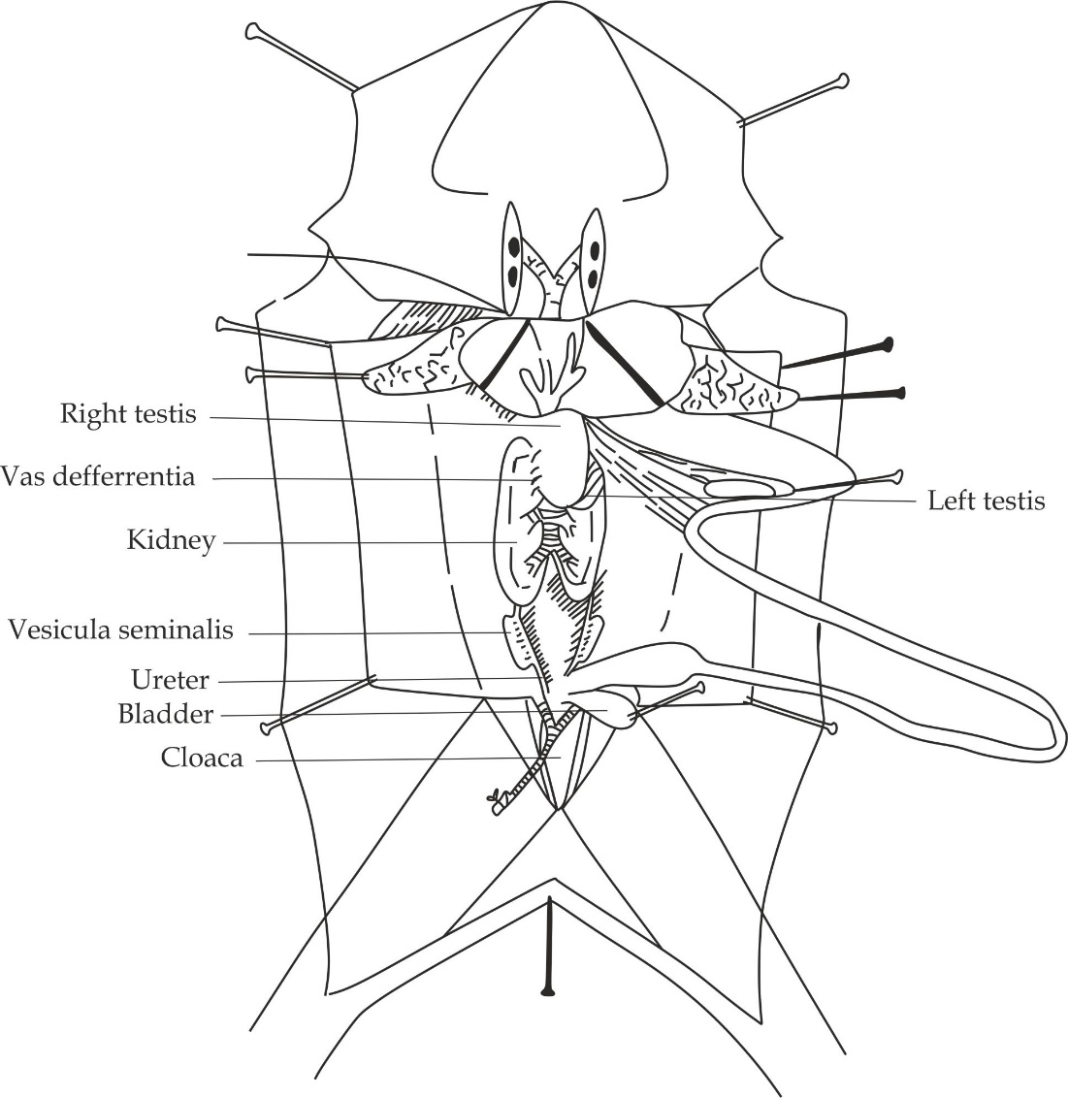

***Figure 2.6*** *urinogenital system of a male frog*

***The female urinogenital system of a frog***

The female urinogenital system of a frog includes fatty bodies, ovaries, oviduct, kidneys, ovisac, ureters, bladder and cloaca as shown in Figure 2.7.

1. **Fatty bodies**

These are yellowish spaghetti like structures located on the upper lips of the ovaries.

Role of fatty bodies

1. They serve asnutrients or energy storage which nourishing the developing egg cells.
2. **Ovaries**

It is a long and coiled glandular tube running into the ovisac, if the eggs are not fully developed, the oviduct will be small and tightly coiled.

Role of oviduct

1. It carries the developing egg cells from the ovaries to the ovisac for the maturation and storage.
2. **Ovisac**

It is a dilated posterior region of the oviduct.

Role of ovisac

1. It stores eggs until the laying period.

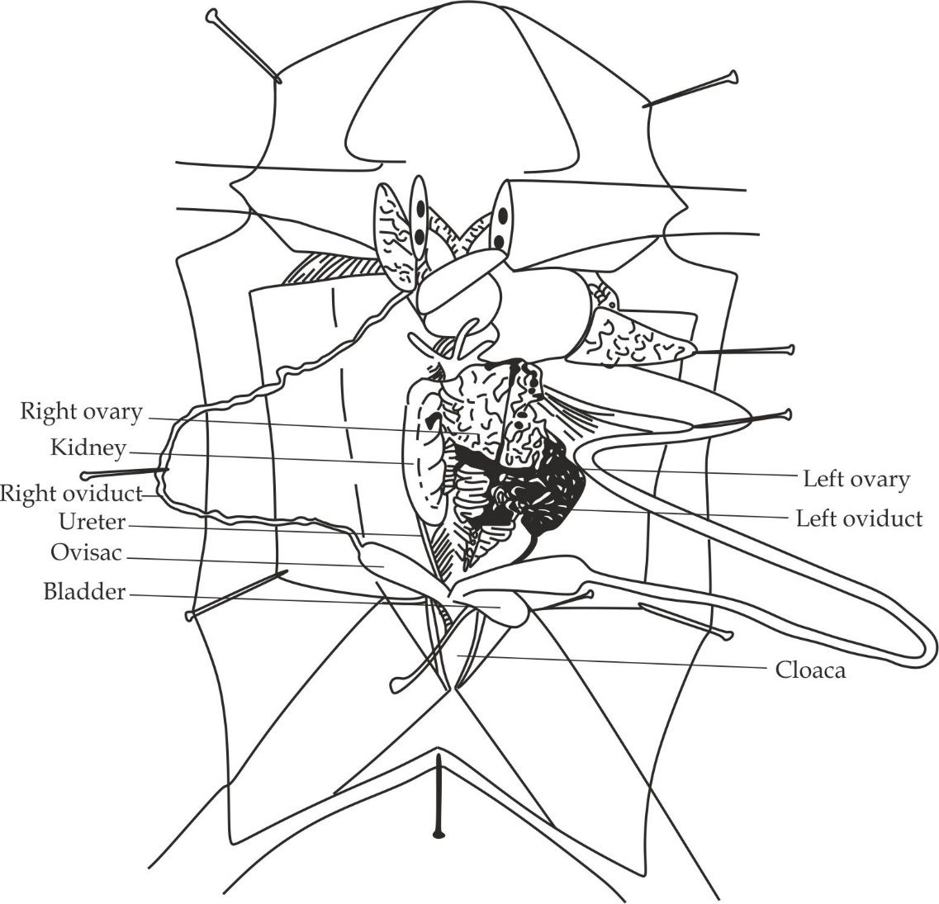

***Figure 2.7*** *urinogenital system of a female frog*

* 1. **NERVOUS SYSTEM OF A FROG**

The nervous system of a frog refers to the set of organs which coordinate activities of organisms. This system must be investigated after completing observation of other system and removing the associated organs.

**Significance of nervous system of a frog**

1. It helps to maintain a constant body state.
2. It accelerates the activities of various organs in the body.
3. It stores the information so that behavior can be modified according to the past experience.
4. It helps to detect the external environment through various sense organs.

The nervous system of a frog displays the ventral branches of the solid spinal nerves looking like whitish threads called **funiculi**. The spinal nerves of the frog are mixed nerves for the reason that; their posterior roots contain sensory axons and their anterior roots contain motor axon hence are capable of transmitting messages in both directions. The ventral branches consist of the following 10 spinal nerves as shown in Figure 2.8.

1. **Hypoglossal nerve**

It is the first spinal nerves comes out between the first and second vertebrae. It controls the muscles of the tongue, jaw and hyoid.

1. **Brachial plexus**

It is the second and third spinal nerves come out between the second and third vertebrae. It controls the shoulder, forelimb and all internal organs found on the proximal part such as heart, liver.

1. **Skin spinal nerves**

It is the fourth, fifth and sixth spinal nerves are small nerves going obliquely to the skin and muscles of the abdomen. It controls the skin body wall.

1. **Sciatic plexus**

It is the seventh, eighth and ninth spinal nerves pass almost directly backward and join to form the sciatic plexus. It controls the thigh, hind limbs and all organs found on the caudal part such as intestine’

1. **Coccygeal nerve**

It is the tenth spinal nerve which controls the muscles of the bladder and cloaca.

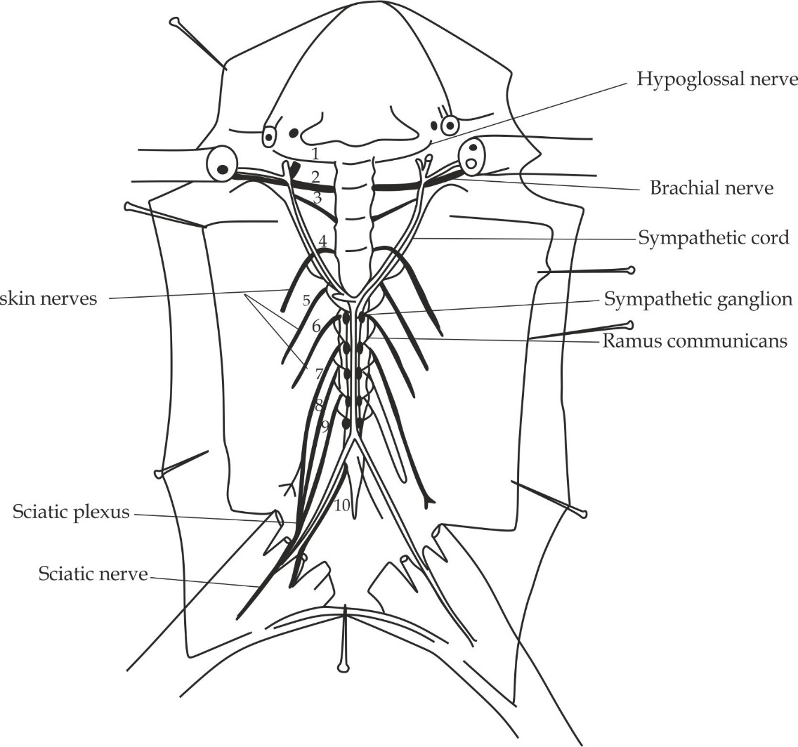

***Figure 2.8*** *nervous system of a frog*

**2.6 DISSECTING PROCEDURES AND SELF CHECK QUESTIONS**

***Dissecting procedures of a frog***

**Requirements:**

* Freshly killed frog
* Dissecting tray
* Dissecting pins
* Forceps
* Scalpel
* Thread

**Step one:**

Place the frog in the dissecting tray or dish with ventral side (abdomen) facing upward.

**Step two:**

Use scissors or forceps to lift the abdominal cavity away from the body cavity, then make a slit incision and cut along the midline from the pelvis to the pectoral girdle as shown in the diagram below, make horizontal cut near the arms and legs as shown in Figure 2.9.

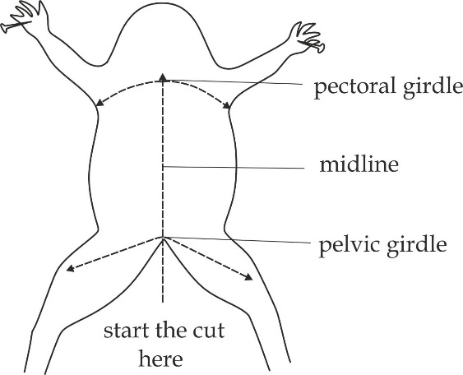

***Figure 2.9*** *horizontal and midline cut of a frog*

**Step three:**

Stretch the skin and pin it back. Make an incision on the body wall then lie two positions on the abdominal vein and ligature between the thread, this prevents blood from flowing in the specimen during dissection for proper display.

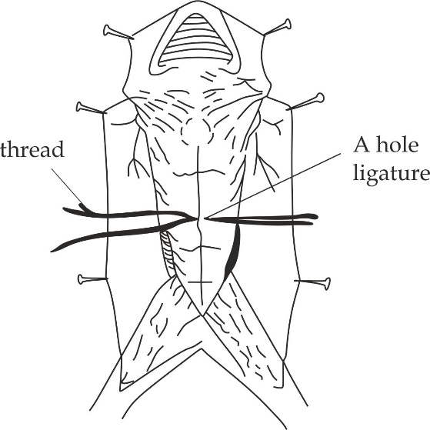

***Figure 2.10*** *ligature of the frog’s abdominal vein*

**Step four:**

By using a pair of scissors; cut the sides of thread forward up the xiphesternum and backward to the pelvic girdle.

**Step five:**

Cut the body wall along the pelvic girdle, first remove a piece which hold the anterior abdominal vein; do the same to pelvic girdle by removing the piece which hold posterior abdominal vein as shown in figure 2.11, stretch the transparent skin and pin it. Make a general identification of **organ in situ**.

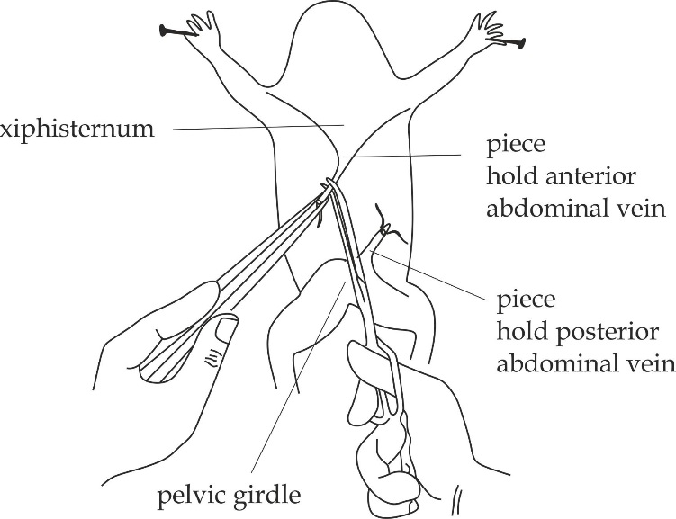

***Figure 2.11*** *remove the piece hold anterior and posterior abdominal vein*

**Step six:**

In displaying **the digestive system:**

* Pin out the stomach to either side of the specimen.
* Pin out the lungs.
* Turn the liver lobes forward and hold them in place with pins.
* Grip the ileum to cut the mesentery and loosen the coils; but do not cut the mesentery of the duodenum and rectum.
* Rearrange the duodenum in position to expose the pancreas and pin out the ileum to your right or left side to make all features visible.

***Note***

**Students**

You’re left your left

Your right you’re right

**Specimen**:

Specimen left your right

Specimen right your left

**Step seven:**

In displaying **the urinogenital system**:

* Cloaca should be opened by removing the ventral portion of the pelvic girdle.
* In case of female frog pin the right ovary on top of the left ovary; loosen and pin out the right oviduct and pin the bladder aside.

**Step eight:**

***In displaying*** **the nervous system**:

* Remove all the digestive organs such as esophagus, stomach and other parts of the alimentary canal.
* Remove the urinogenital system, when removing the kidney, take care not to cut the aorta.
* Remove the remaining membranes to expose the spinal nerves.
* Cut the flesh of the pelvic girdle through both things and trace the sciatic plexus formed by the seventh, eighth and ninth spinal nerves and the sciatic nerve which passes down the leg close to the femur.
* Trace the sympathetic cords on either side of the aorta, notice the sympathetic ganglia and identify the rami communicans between the spinal nerves and the sympathetic ganglia.

***Self-check questions***

1. **DAR MOCK 2018; 3B**

You have been provided with specimen X**:**

1. Dissect it in the usual way to full display the visceral in situ.
2. Make a large, neat and well labelled diagram of your dissection.
3. Leave your dissection properly displayed for assessment.
4. How is specimen X adapted to its mode of life?
5. **NECTA 2005; 3A**

You are provided with specimen S1; dissect the specimen in the usual way to fully display the visceral in situ.

1. Draw a large labelled diagram of your dissection.
2. What is the importance of the following procedures followed during the dissection
3. Tying/ ligaturing the anterior vein.
4. Flooding the dissected specimen with water.
5. **PRE NECTA SOUTHERN ZONE**

You are provided with specimen Q; dissect the specimen in the usual way to fully display the visceral in general.

LEAVE YOUR DISSECTION WELL AND PROPERLY DISPLAYED FOR ASSESSMENT

1. Draw a well labelled diagram of your dissection.
2. State the sex of your specimen and give one feature used to determine the sex.
3. Define the term metamorphosis in amphibian.
4. State the type of metamorphosis that your undergoes.
5. Name the function of the following structures:
6. Pancreas
7. Duodenum
8. Rectum
9. cloaca
10. Give three adaptive features of specimen **Q** to its mode of life.
11. **NECTA2006; 3A**

You have been provided with specimen D; dissect the specimen in the usual way to fully display the digestive system.

1. Deflect the digestive system to your right side.
2. Make a large, neat and well labelled diagram of your dissection.
3. Carefully, examine the digestive system with hand lens and name the structure in the digestive system which is responsible for temporary storage of food
4. Leave your dissection well displayed for assessment.
5. **MWANZA MOCK 2012; 3A**

You are provided with specimen S1, Dissect it in usual way to display the alimentary.

1. Pin the tongue aside on the right hand side of the specimen S1.
2. Display the remaining part of the digestive system to the left hand side of the animal.
3. Make a larger, neat and well labelled diagram of your dissection.
4. Leave your dissection properly displayed for assessment.
5. **NECTA 2004, 3A**

You have been provided with specimen S1.

1. Dissect it in the usual way to display the urinogenital system.
2. Make a large, neat well labeled diagram of your dissection.
3. State the sex of your specimen and give one feature you used to determine sex.
4. LEAVE YOUR DISSECTION WELL DISPLAYED FOR PROPERY ASSESSMENT.
5. **NECTA 2008, 3A**

You are provided with specimen S1, Dissect it in the usual way to fully display the urinogenital system, deflect the alimentary canal to the left hand side of the specimen so as to clearly show the required system.

1. Draw a large diagram of the dissection and label only the structures related to the system displayed.
2. Name the sex of the specimen.
3. Classify S1 to class level.
4. **MWANZA MOCK 2011, 3B**

You are provided with specimen Z, dissect it in usual way to full display urinogenital system. Displace the alimentary canal of your specimen to your right hand side and urinary system on your left hand side.

1. Label the required parts only, leave your specimen properly for assessment.
2. Which structure concern with storage of eggs and sperms ready for fertilization.
3. In what ways reproductive organs of the specimen Z differs from that of human?
4. **MTWARA AND LINDI MOCK 2021**

You have been provided with specimen S1, Dissect it in a usual way to fully display the nervous system.

LEAVE YOUR DISSECTION WELL DISPLATED FOR ASSESSMENT

1. Draw a well labeled diagram of your dissection.
2. Which organ (s) in the animals:
3. Served as hypoglossal nerve.
4. Served as sciatic nerve.
5. Served as brachial nerve.
6. Name three (3) adaptive features of specimen S1 to its mode of life.
7. **PRE NATIONAL 2022**

You have been provided with specimen K. Dissect it in usual way to fully display the nervous system.

LEAVE YOUR DISSECTION WELL DISPLAYED FOR ASSESSMENT

1. Draw a large, neat and well labeled diagram of your dissection.
2. Write the role of each of the following observed nerves:
3. Coccygeal nerve
4. Hypoglossal nerve
5. Sciatic nerve (plexus)
6. Skin spinal nerves
7. Suggest the sex of specimen K and give one internal feature you have considered.
8. State five features which help specimen K to adapt to its mode of life.
9. **FEZA BOYS 2019**

You’re provided with specimen A. Dissect it in the usual way to fully display the spinal nerves. Not that it is important to remove stomach, lungs, heart and the floor of the mouth as well as the kidneys. Take care not to cut the aorta.

1. Draw a large neat and well labelled diagram of your dissection. Leave your dissection well displayed for assessment.
2. i. What are spinal nerves and what is their general functions.
3. What does the following statement mean? All spine nerves are mixed nerves?
4. What is the importance of the following procedures followed during dissection?
5. Tying/ ligaturing the anterior abdominal vein.
6. Flooding and dissected specimen with water.
7. **DISSECTION OF A RAT**

At the end of the dissection of a **rat**, a student should be to understand the following aspects:

* 1. Introduction of a rat
  2. Viscera in situ of a rat
  3. Digestive system of a rat
  4. Reproductive system of a rat
  5. Dissecting procedures and self-check questions of a rat
  6. **INTRODUCTION OF A RAT**

A ***rat*** is commonly used in dissection work as the representative of class mammalian in the phylum chordata.

**Common name**: Rat

**Habitat**: It is found in tunnel or burrow.

**Mode of nutrition**: Holozoic nutrition (herbivores)*.*

**Mode of reproduction**: Internal fertilization.

**Taxonomy classification of a rat:**

**Kingdom**: Animalia

**Phylum**: Chordata

**Class**: Mammalian

**Order**: Rodential

**Family**: Maridae

**Genus:** Rattus

**Species:** Rattus

**Distinctive characteristics of a rat**

1. It has mammary glands, which produces milk for their newborn.
2. It is warm blooded animal.
3. It has four heart chambers.
4. It has lungs for gaseous exchange.
5. It undergoes internal fertilization.
6. It has body covered with hair fur.
7. It has heterodent dentitation for different functions.
8. It has muscular diaphragm, which separates thorax from abdomen

**Adaptations of a frog to its mode of life**

1. Presence of fur to reduce water loss and regulate body temperature.
2. Presence of nostrils with whiskers to detect smell.
3. Presence of long incisors in the upper jaw of the mouth for cutting.
4. Presence of digits on the limbs modified to form claws for digging and burrowing in tunnels.
5. Presence of pentadactyl limbs for locomotion and support.
6. Presence of long tail for body balance.
7. Presence of larger pinna to detect sound signals.

**Table 3.1 sex identification of a rat**

|  |  |
| --- | --- |
| **Male frog** | **Female frog** |
| Absence of nipples (teats) | Presence of nipples |
| Presence of testes | Presence of ovaries |
| Presence of penis | Presence of vagina |
| Presence of scrotum | Presence of clitoris |

**Economic importance of a frog**

1. It is used in biological studies as a specimen for dissection.
2. It is used as food by other organisms.
3. It is used in biological control.
4. It destroys properties such as crops and clothes.
5. It is used in biological research as a diagnostic tool for tuberculosis (TB).
   1. **VISCERA IN SITU OF A RAT**

Viscera in situ of a rat includes all the internal organs in the abdominal cavity in undisturbed condition.

***Visceral in situ of a male rat***

Visceral in situ of a male rat composed of liver, stomach, spleen, pancreas, small intestine, caecum, colon, bladder, heart, lungs and male organs such as penis, prostate gland, preputial gland as shown in figure 3.1.

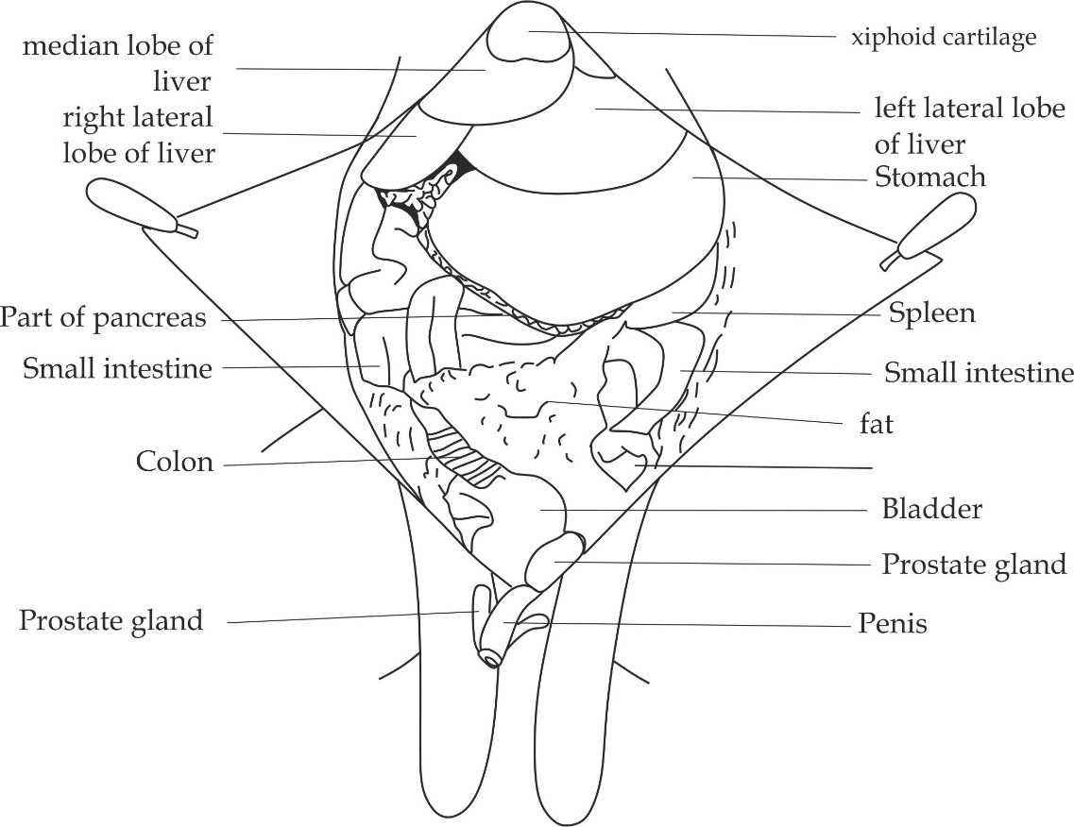

***Figure 3.1*** *viscera in situ of a male frog*

***Visceral in situ of a female rat***

Visceral in situ of a female rat composed of liver, stomach, spleen, pancreas, small intestine, caecum, colon, bladder, heart, lungs and female organs such as preputial gland, clitoris and vagina orifice as shown in figure 3.2.

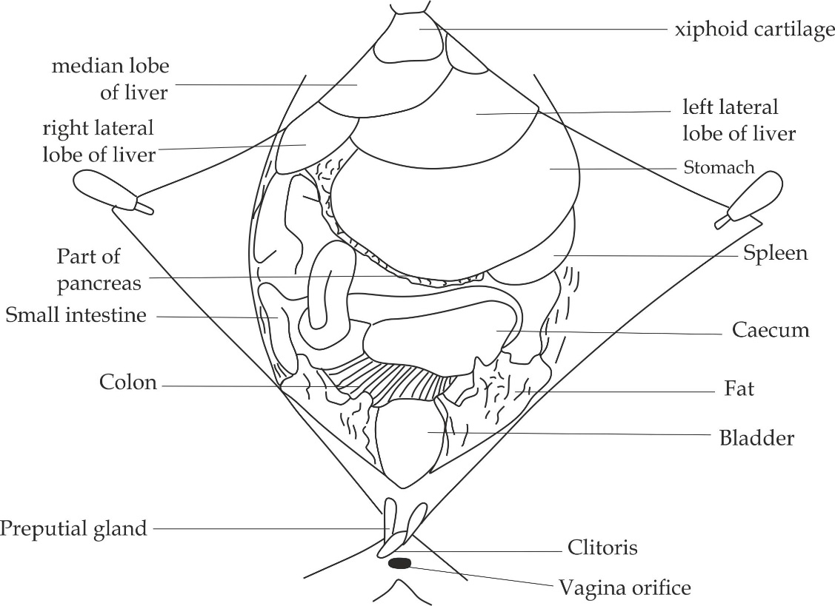

***Figure 3.2*** *viscera in situ of a female rat*

* 1. **DIGESTIVE SYSTEM OF A RAT**

The alimentary canal of a rat starts from the mouth to the anus. A rat digestive has two major differences with that of a human. ***Firstly***; Rats do not have a gall bladder which is used for storing bile, this is because they rarely take in large amount of fatty foods, thereby, making a gallbladder useless. ***Furthermore***; rats contain very large intestine called caecum which contains bacteria that digest cellulose. It includes mouth, esophagus, stomach, accessory organs (*liver, pancreas and spleen*), small intestine (*duodenum, jejunum and ileum)*, large intestine *(caecum, colon, rectum and* *anus)* as shown in Figure 3.3.

1. **Mouth**

The mouth consists of sixteen teeth; twelve molar and four incisors (two on the upper jaw and the other two on the lower jaw), the lower incisors are more developed, pointed, sharp and longer than the rest.

Roles of mouth

1. For mechanical digestion of food by cutting the food into pieces.
2. For chemical digestion of starch.
3. **Esophagus**

It is a short elastic tube with circular and longitudinal muscles.

Role of esophagus

1. It allows the peristalsis movement of bolus food into the stomach.
2. **Stomach**

It is a muscular pouch arising from the lower lip of the esophagus and it is partially covered by the liver lobes.

Role of stomach

1. For temporary storage of food.
2. For mechanical digestion due to contraction of muscles.
3. For chemical digestion of protein due to the presence of pepsin.
4. **Accessory glands**

The digestive accessory organs of the rat include the liver, pancreas and spleen.

1. **The liver;** It is the largest dark brownish coloured organ suspended just under the diaphragm. The liver of the rat has four lobes; one on the left, two on the right and one on the middle.

Roles of liver

1. For production of bile.
2. For detoxification of toxic substances into harmless.
3. For storage of excess glucose in form of glycogen.
4. **The pancreas;** It is the brownish flattened gland lies beneath the stomach.

Roles of pancreas

1. It produces pancreatic enzymes for digestion of protein, lipids and carbohydrates.
2. It produces insulin hormone for regulation of glucose.
3. **The spleen**; It is a dark red banana shaped organ attached to the greater curvature of the stomach.

Role of spleen

1. For destruction of blood cells.
2. For storage of blood.
3. **Small intestine**

It is the slender and narrow tube which connects the stomach to the large intestine. It consists of three sections, the first non-coiled part called ***duodenum***, the middle short and coiled section called ***jejunum*** and the terminal long and coiled part of the small intestine called ***ileum***.

Role of small intestine

1. For final digestion and absorption of food.

Adaptations of small intestine

1. It has villi which increase the surface area for absorption of digested food materials.
2. It is long to increase surface area for absorption of food materials.
3. It is highly coiled to increase time for absorption of food materials.
4. It has microvilli which increase surface area for absorption of food materials.

***Note***

The hepatic portal veins runs from the liver to the intestine covered by chain of lymph nodes and form branches in the mesentery which attach the intestine to ensure maximum absorption of digested food and also allow the supply of blood and nerves to the intestine.

1. **Large intestine**

It is the shorter and wider greenish tube extends from the ileum and leads to the anus.It is divided into four sections which are caecum, colon, rectum and anus.

1. **Caecum**

It is a pouch that connects ileum to the colon. The vermiform appendix is a blind ended sac attached to the caecum.

Roles of caecum

1. It stores undigested food temporary before being passed to the colon.
2. It contains bacteria which breaks cellulose into glucose.
3. **Colon**

It consists of ascending, transverse and descending segment.

Role of colon

1. For reabsorption of water from undigested food (faeces).
2. **Rectum**

It is a short and terminal section of the large intestine.

Role of rectum

1. It stores undigested food temporary before removed out of the body cavity periodically by defecation process.
2. **Anus**

It is the part which allows the elimination of solid undigested food substances out of the gut.

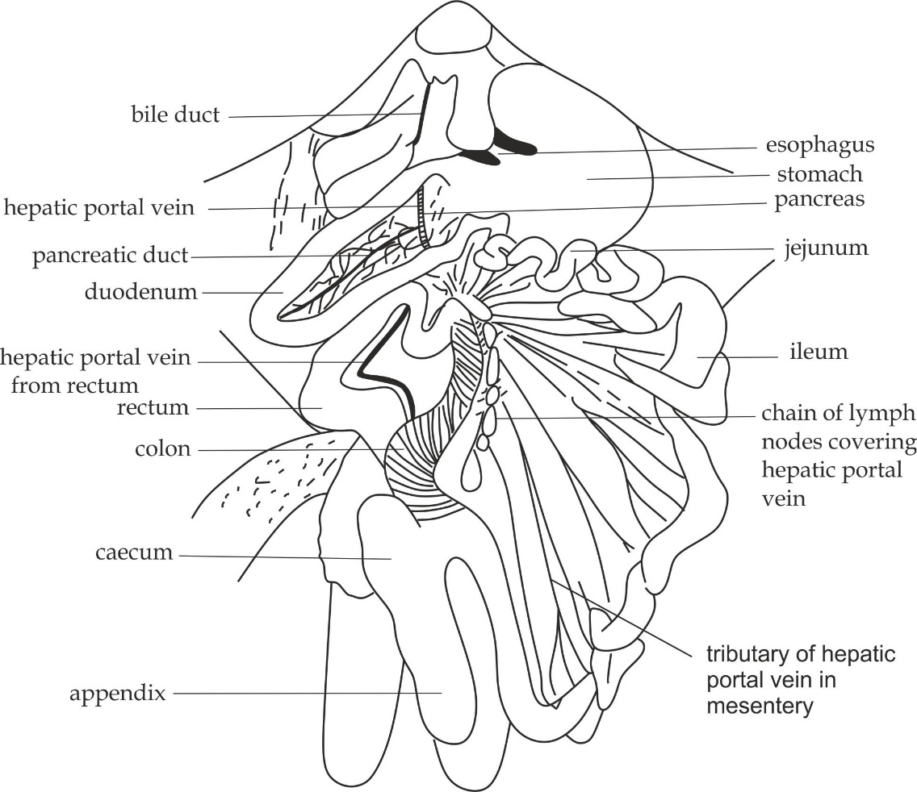

***Figure 3.3*** *digestive system of a rat*

* 1. **URINOGENITAL SYSTEM OF A RAT**

In rats, the urinary and reproductive system are investigated in the some ways and are usually studied together as urinogenital system. However, the excretory system eliminates waste products and the reproductive system produces sperms in males and egg cells in females. There are two main urinogenital system to be studied:

* The male urinogenital system of a rat.
* The female urinogenital system of a rat.

***The male urinogenital system of a rat***

The urinogenital system of a male rat includes nine (9) organs which are kidneys, ureters, urethra, bladder, penis, male sex glands (*Cowper’s glands, prostate glands*, *and preputial glands),* testes, epididymis, vas deferens and seminal vesicles as shown in figure 3.4.

1. **Kidneys**

These are two dark brown coloured bean shaped organs located on the back of the abdominal cavity on either side of vertebrae.

Role of kidneys

1. They excrete metabolic wastes.
2. **Ureters**

These are two narrow whitish tubes extending from each kidney to the urinary bladder.

Role of ureters

1. They carry urine from the kidneys to the urinary bladder.
2. **Urinary bladder**
3. It stores urine temporary before removed during urination process.
4. **Urethra**

These are small tubes which join excretory and reproductive system.

Role of urethra

1. It conducts sperms and urine out of the reproductive system.
2. **Penis**

It is the organ made by the sponge muscles associated with numerous blood capillaries which when filled with blood erection is achieved.

Role of penis

1. It deposits sperms into female reproductive system during mating.
2. **Male sex glands**

There are three types of male sex glands which are Cowper’s glands, prostate glands and preputial glands.

1. **Cowpers glands**; these are small ovoid shaped glands found at the root of the penis. It secretes alkaline fluid which neutralizes the acid substances left by the urine in the urethra during ejaculation.
2. **Prostate glands;** these are paired accessory glands located near the base of the *seminal vesicle*. It secretes fluids reach in fructose to nourish the sperms.
3. **Preputial glands;**

These are glands each wrapped on either side of the ventral wall of penis.They usually attract females.

1. **Testes**

These are ovoid shaped male gonads enclosed by the scrotal sacs.

Role of testes

1. They produce sperms and male sex hormones.
2. **Epididymis**

These are highly coiled tube connected to the testes.

Role of epididymis

1. For temporary storage and maturation of sperms.
2. **Vas deferens**

These are tubes which connects sperms and urine from epididymis to the urethra.

1. **Seminal vesicles**

These are folded glands located at the base of the urinary bladder**.**

Role of seminal vesicles

1. They store sperms before been ejaculated during mating.

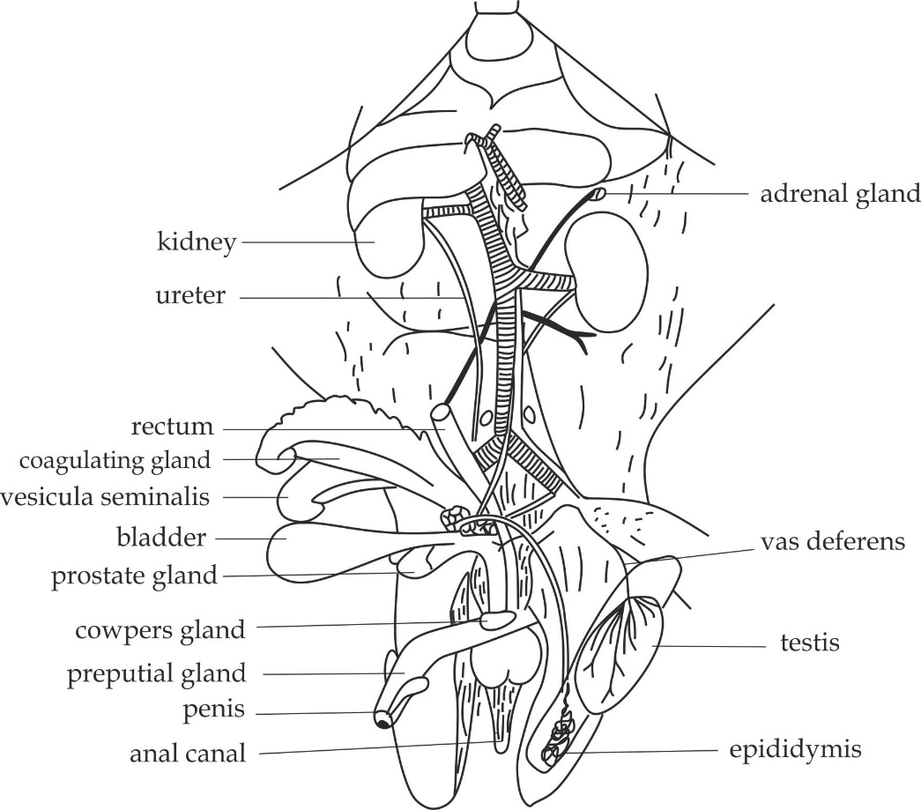

***Figure 3.4*** *male urinogenital system of a rat*

***The female urinogenital system of a rat***

The urinogenital system of a female rat includes eight (8) organs which are kidneys, ureters, urethra, bladder, ovaries, oviducts (*fallopian tubes*), uterus and vagina as shown in figure 3.5.

1. **Kidneys**

These are two dark brown coloured bean shaped organs located on the back of the abdominal cavity on either side of vertebrae.

Role of kidneys

1. They excrete metabolic wastes.
2. **Ureters**

These are two narrow whitish tubes extending from each kidney to the urinary bladder.

Role of ureters

1. They carry urine from the kidneys to the urinary bladder.
2. **Urinary bladder**
3. It stores urine temporary before removed during urination process.
4. **Urethra**

These are small tubes which join excretory and reproductive system.

Role of urethra

1. It conducts egg cells and urine out of the reproductive system.
2. **Ovaries**

These are female gonads of the rat which are found at the tip of the uterus. They are enclosed within a thin walled ovarian sac surrounded by the fats.

Role of ovaries

1. They produce egg cells (ova) and female sex hormones.
2. **Oviducts (fallopian tubes)**

These are extremely thin coiled tubes that connects the ovaries to the uterus.

Role of oviducts

1. They are sites for fertilization.
2. **Uterus**

These are long duplex tubes on either sides above the vagina.

Role of uterus

1. It is a site for implantation whereby embryo development occurs.
2. **Vagina**

It serves as a birth canal and also receives penis during copulation.

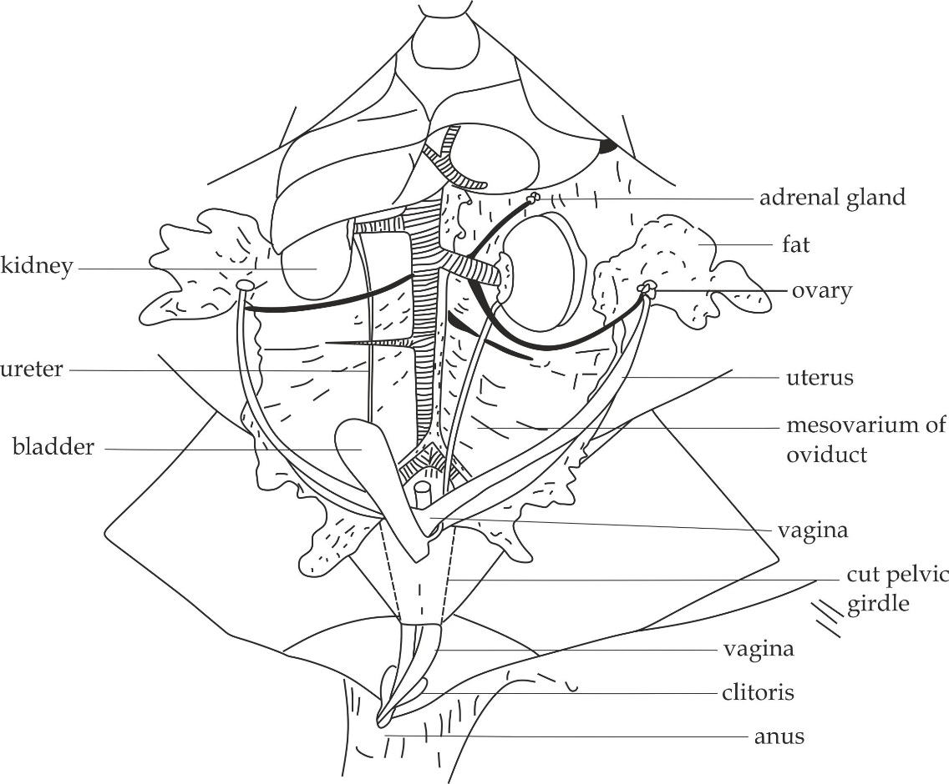

***Figure 3.5*** *female urinogenital system of a rat*

* 1. **DISSECTING PROCEDURES AND SELF CHECK QUESTIONS**

***Dissecting procedures of a rat***

**Requirements:**

* Freshly killed rat
* Dissecting tray
* Dissecting pins
* Forceps
* Scalpel

**Step one:**

Place the rat in the dissecting tray or dish with ventral side (abdomen) facing upward. Pin it down on the tray through the fore and hind limbs as shown in figure 3.6.

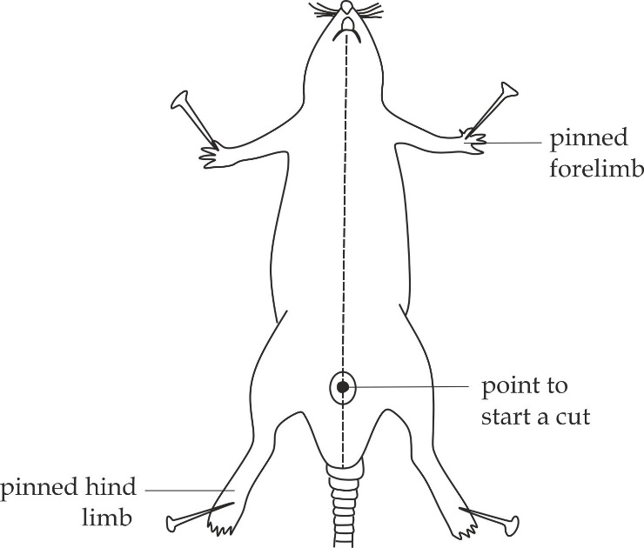

***Figure 3.6*** *positioning the rat for dissection*

**Step two:**

Lift the skin in the mid – ventral line using forceps, and cut to make a small slit as shown in figure 3.7. Cut forward to the level of the lower lip and backwards around the penis and between the scrotal for a male specimen while the female cut the skin backward as far as the anus, passing either side of urinary and genital apertures.

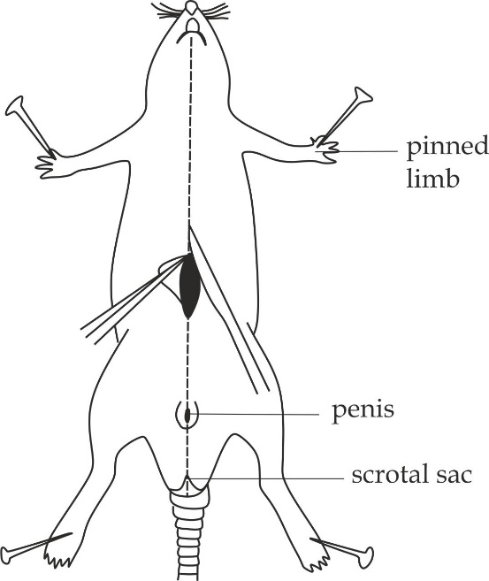

***Figure 3.7*** *opening the body cavity of a rat*

**Step three:**

Use fingers to pull the skin aside, loosen it from the body wall, stretch it and pin it back.

**Step four:**

Lift the abdominal wall using forceps, make an incision and cut up to the xiphoid cartilage and down to the left and right ribs. Stretch the body wall and pin it aside as shown in figure 3.9. Examine the content of the abdominal cavity in undisturbed condition (in situ/ general view) and draw a well labelled diagram.

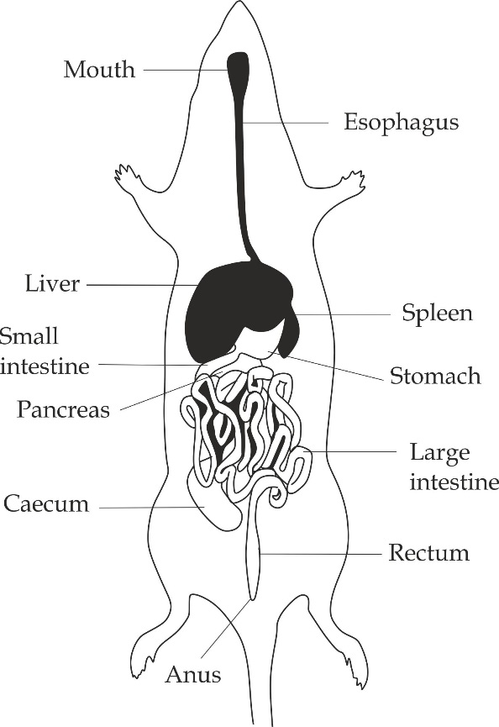

***Figure 3.8*** *general view of the dissected rat*

**Step six:**

To display ***the digestive system*,** adjust the positions of the alimentary canal by moving the bulk of the intestine to left hand side of the specimen to expose the duodenum and the colon. Grip the duodenum and colon, pull them apart to expose hepatic portal vein and turn the bulk of the intestines over to untwist them, rearrange the digestive structures and draw a well labelled diagram. (*Remember the displacement of digestive system is similar to that of a frog, that is; your left hand side is your left and left side of the specimen is your right hand side and vice versa).*

**Step seven:**

When ***displaying urinogenital system***, the alimentary canal should be removed first followed by the removal of fats from the kidneys using blunt forceps and clear the ureter.

**Step eight:**

In ***male rat***, open the scrotal sac by cutting its ventral wall to expose thetestes, caput epididymis as well as the vas deferens. Lay the bladder, seminal vesicles, coagulating glands and prostate glands on one side.

**Step nine:**

In ***female rat*,** grip the clitoris, pull it gently so that the urethra is held away from the pelvis, and cut the ventral part of the girdle, lift the oviducts and remove the mesovarium to expose ureters on both sides, remove the fat bodies from the kidneys and ureter, but leave them around the ovaries (the ovaries are enclosed within the thin walled ovarian sac and connected to a very small and much coiled fallopian tube) and observe the very long tube called fallopian tube near to the uterus.

***Self-check questions***

1. **NECTA 1998,3A**

Open the abdominal cavity of the specimen S1 in the usual way carefully move the bulk of visceral contents to your left and rearrange but with minimum disturbance, the various parts so as to display them fully:

1. Draw a large and neat diagram of the dissection.
2. Using letters **A – I** label on the diagram the organs and structures concerned with functions listed below:

|  |  |
| --- | --- |
| **Label** | **Function** |
| A | Temporary storage of the food |
| B | Exocrine and endocrine system |
| C | Final digestion of food and intensive absorption |
| D | Transportation of products of digestion from the liver |
| E | Active absorption of water |
| F | Production of bile |
| G | Reception of chyme |
| H | Temporary storage of undigested of food remnants |
| I | Microbial breakdown of cellulose |

1. Give the biological names of the structures A – I.
2. What two products of digestion are transported by the structure D?
3. Mention two other roles of each of the structures A and F. LEAVE YOUR DISSECTION PROPERLY DISPLACED FOR ASSESSMENT.
4. **DAR MOCK 2004**

You’re provided with specimen labeled M dissect it in usual way to display the digestive system putting the gut on your right hand side.

1. Draw a well labeled diagram of the displayed system.
2. Analyze the main parts associated with the displayed system giving out its main functions.
3. Classify the specimen to its order level.
4. Explain the main adaptations of the specimen to its mode of life.
5. **NECTA 2009, 3A**

You have been provided with specimen S1. Dissect specimen S1 in the usual way to full display the contents of the abdomen (viscera).

1. Pin aside the abdominal wall. Examine the contents of abdominal cavity in the undisturbed condition. Draw a large diagram and label the content of the abdomen.
2. Name the accessory organs of the digestive system and state three roles of each.
3. Name the structure responsible for water reabsorption.
4. LEAVE YOU’RE DISSECTION WELL DISPLAYED FOR PRPERLY ASSESSMENT.
5. **NECTA 2001, 3A**

You have been provided with specimen S1.

1. Identify the sex of your specimen. Display specimen S1 in the usual way to full display the excretory system.
2. Draw a large, neat diagram of your dissection and label only the excretory structures and blood vessels associated with the system.
3. State one function of only four of the excretory structures labeled in (b) above.
4. LEAVE YOUR DISSECTION WELL DISPLAYED FOR PROPERLY ASSESSMENT.
5. **LAKE ZONE 2008**

Your given specimen L dissect specimen L in a usual way putting the gut on the left side of the specimen to display the urinogenital system.

1. Draw a well labeled diagram to show a displayed system.
2. What are the main parts and roles of the system in question above?